Kubeflow pipeline steps as follow:
Click on upload the pipeline and below sequence will start or the options can be change
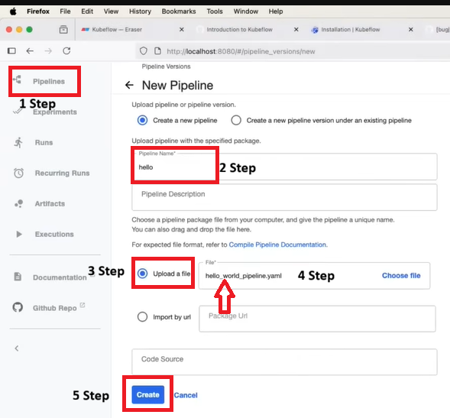
After creating a pipeline below page will open
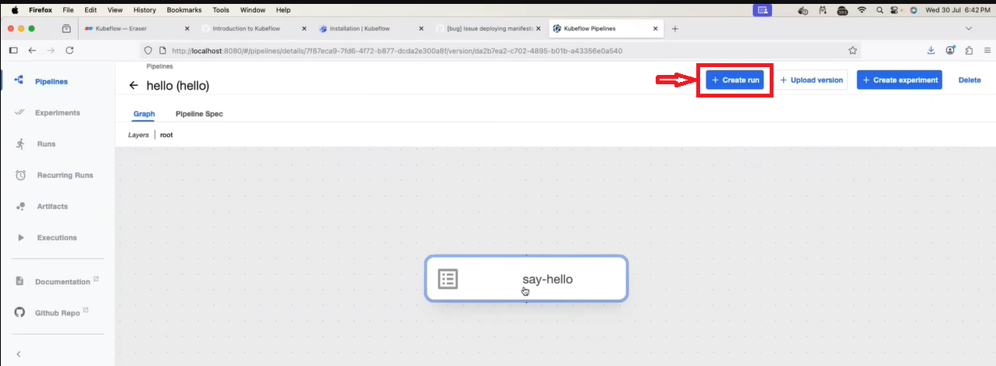
if you given more than one parameters that will reflect here
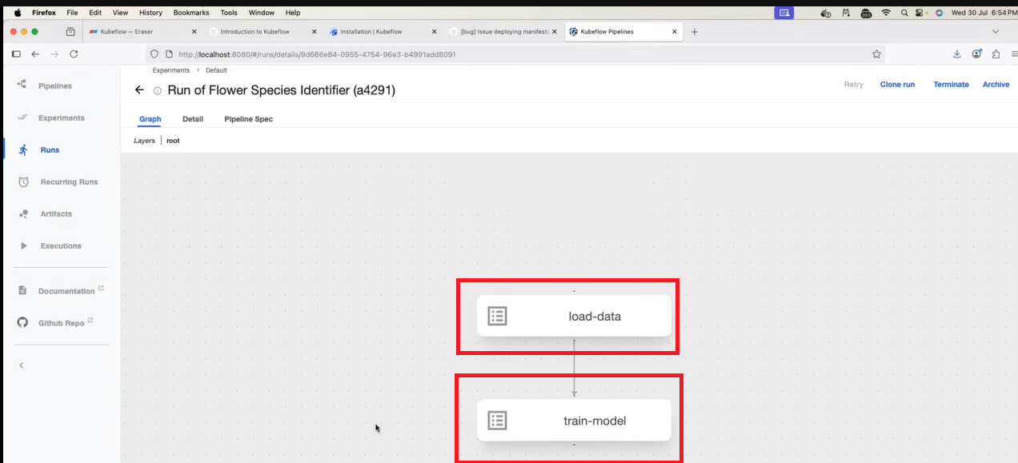

Click on “Create run”
Select or Provide the parameters highlighted as below:
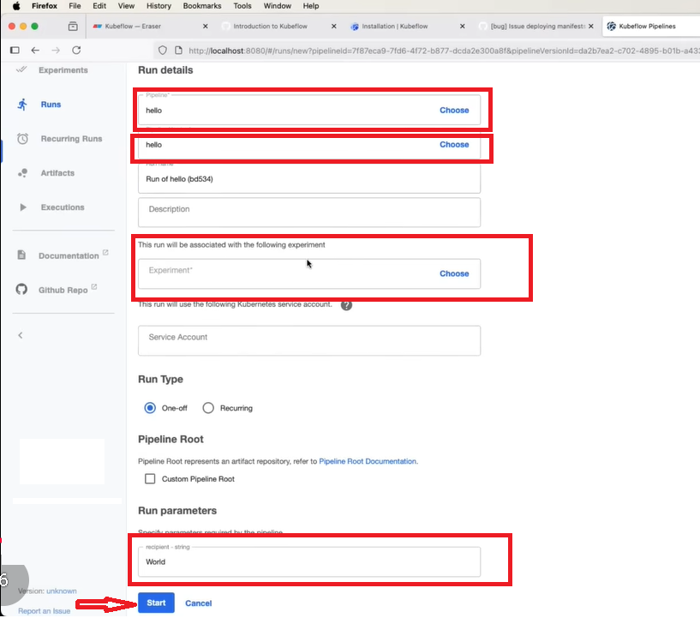

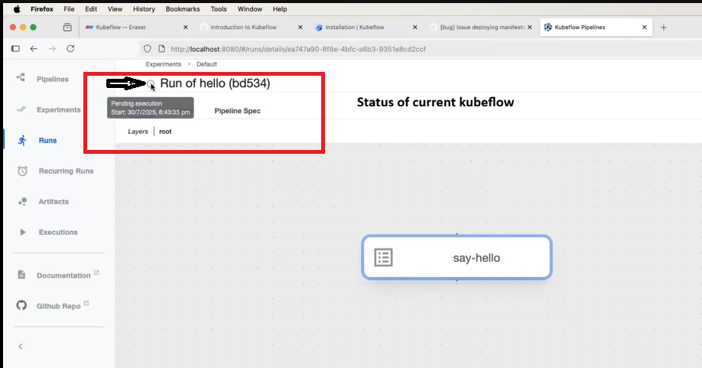
Check the pod status in terminal using a command below:
Kubectl get pods -n Kubeflow
Implementation pods take time to start as it is go from Initialization Running Completed
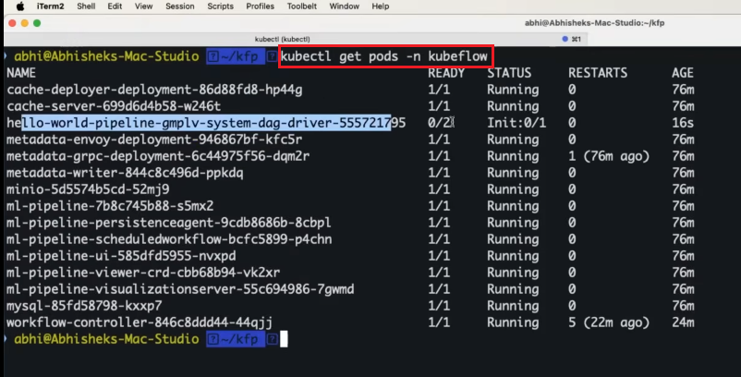
Once pod is ready to serv the traffic below page can see
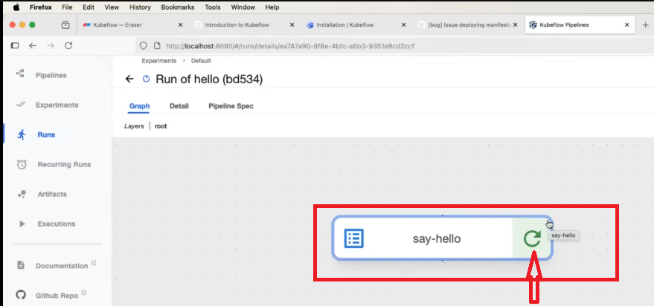
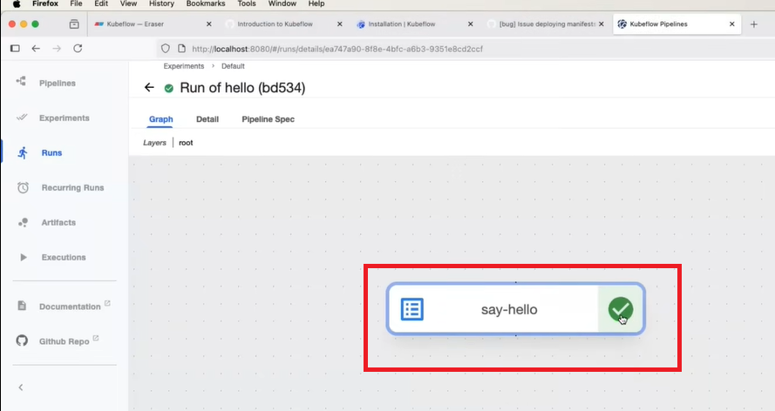
Click on the right sign green and you can see the input output details, logs and events as follow:
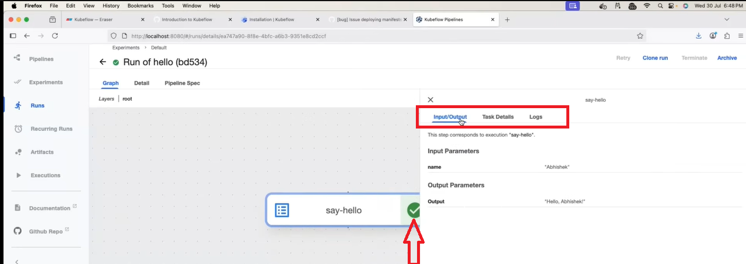
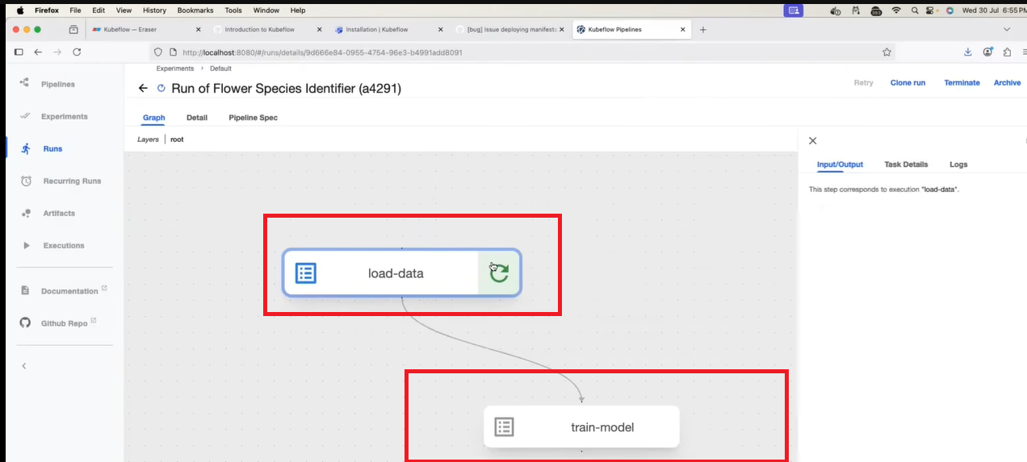

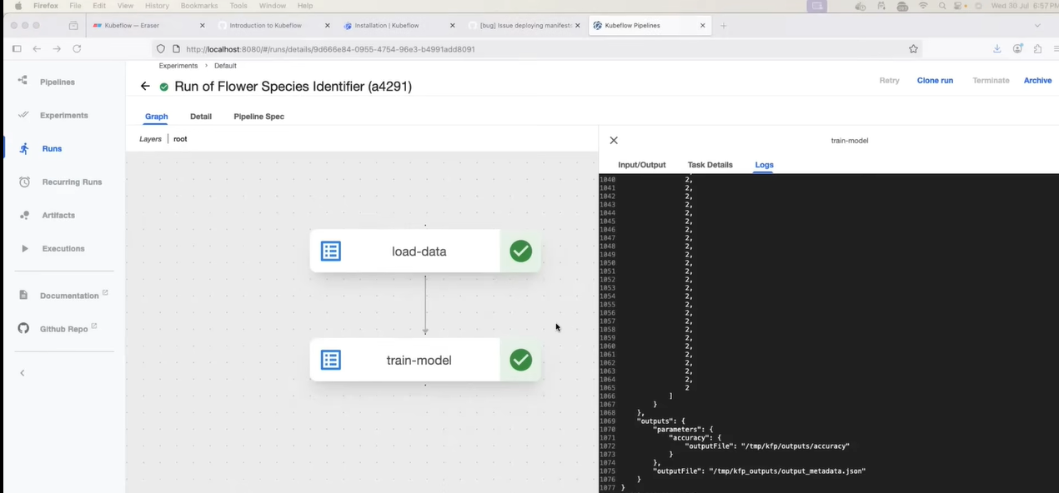

You can re-run the Kubeflow pipeline providing the parameters again
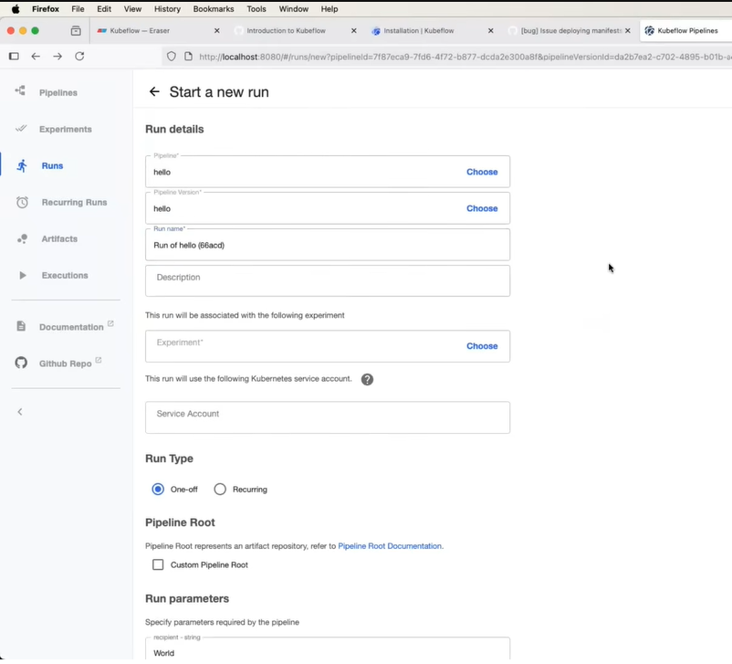

[Raw SQL/CSV] ➔ [Prefect Orchestration] ➔ [DVC Versioning] ➔ [MLflow tracking] ➔ [FastAPI + Docker] ➔ [GitHub Actions CI/CD] └──> [Evidently AI Monitor]

I have project wherein there are many reseller and each reseller have multiple customer and each customer have many subscription for monthly and annually basis customer have option for auto renew the subscription on renewal date so How I can build MLOps project on this scenario to catenaries customer tier.

The Customer tier rules

if they enable auto renewal and have with more than 3 years customer can be elite and if they have more than 5 subscription

if the customer have less than 5 subscription and with us more than 3 years Pro+

if the customer have less than 5 subscription and with us less than 3 years but disabled the auto renewal Pro

if the customer have less than 5 subscription and with us less than 1 years but enable the auto renewal Pro

if the customer have less than 5 subscription and with us less than 1 years and disabled the auto renewal normal

Part 1: How to Explain This Project to an Interviewer

1. The Project Summary (The Elevator Pitch)
"I designed and built a multi-tenant subscription analytics and retention MLOps pipeline. The project handles hierarchical subscription data across three layers: Resellers ➔ Customers ➔ Subscriptions. The system does two things: first, it processes monthly and annual subscription data to group customers into 5 defined operational tiers (Elite, Pro+, Pro, Normal) using a rule engine. Second, it uses a lightweight Machine Learning classifier to predict Auto-Renewal Churn Risk (i.e., which customers are likely to disable auto-renewal next month) so account managers can take proactive retention actions."

2. Project Details
Metric | Project Detail
Project Type | Multi-Tenant Subscription Analytics & Churn Prediction (Tabular / Classification)
Target Variable ($Y$) | will_disable_auto_renew (Binary: 1 for Yes, 0 for No)
Model Type | XGBoost / Random Forest (Lightweight, tabular, explainable, and fast on low compute)
Deployment Stack | MLflow + Docker + FastAPI (Run locally inside 5GB RAM)
Orchestration | Prefect (Very lightweight compared to Airflow, perfect for restricted local memory)
Data Versioning | DVC (Tracks raw SQLite/Parquet files stored in mock local S3)

🛠️ Part 2: Step-by-Step MLOps Pipeline & Tools
Since your local system has limited hardware (5 GB RAM, 3 CPU, 30 GB storage), we will avoid heavy enterprise tools like Kubeflow (which requires at least 16GB RAM just to boot). Instead, we will use MLflow combined with lightweight open-source tools.
[Raw SQL/CSV Data] ➔ [Prefect Rule Engine] ➔ [DVC Data Versioning] ➔ [MLflow Training] ➔ [Docker/FastAPI Deploy]

Step 1: Data Ingestion & Rule-Engine (Data Engineering)
- Goal: Aggregate hierarchical subscriber data and apply your exact Tier Rules.
- Tools: SQLite (lightweight local SQL file) + Pandas + Prefect.
- Flow:
  - Pull active subscription data and aggregate it by customer_id.
  - Compute variables: customer_tenure_years, total_active_subscriptions, and auto_renew_enabled.
  - Run the Rule Engine in Python to tag the customer's tier:
    - Elite: auto_renew == True AND tenure > 3 years AND subscriptions > 5
    - Pro+: subscriptions < 5 AND tenure > 3 years
    - Pro: (subscriptions < 5 AND tenure < 3 years AND auto_renew == False) OR (subscriptions < 5 AND tenure < 1 year AND auto_renew == True)
    - Normal: subscriptions < 5 AND tenure < 1 year AND auto_renew == False
  - Write the final cleaned data containing both the tier label and model features to a local database.

Step 2: Data Versioning (DVC)
- Goal: Track your dataset changes without bloating local storage.
- Tools: DVC (Data Version Control).
- Flow:
  - Once the SQLite file (customer_data.db) is exported, run:
Bash
dvc init
dvc add data/customer_data.db
  - DVC generates a tiny customer_data.db.dvc text pointer. Commit this pointer to Git.
  - The actual heavy dataset is stored in a mock local directory (acting as your S3 bucket). This prevents your 30GB local disk from filling up with old Git history.

Step 3: Experiment Tracking & Model Training (MLflow)
- Goal: Train a model to predict who will turn off auto-renewal, and log the results.
- Tools: MLflow + Scikit-Learn (Random Forest).
- Flow:
  - Use the customer tiers as a highly predictive feature for your classification model.
  - Start an MLflow run in Python to log parameters (e.g., max depth of the tree) and performance metrics (e.g., F1-score, precision, recall):
Python
import mlflow
mlflow.set_tracking_uri("http://localhost:5000")
with mlflow.start_run():
model.fit(X_train, y_train)
mlflow.log_metric("f1_score", f1)
mlflow.sklearn.log_model(model, "churn_model")
  - Launch the MLflow UI (mlflow ui) locally to compare different model versions without consuming much RAM.

Step 4: Model Deployment (FastAPI + Docker)
- Goal: Package the model into an API that your reseller application can query.
- Tools: FastAPI + Docker.
- Flow:
  - Create a lightweight main.py using FastAPI. The endpoint /predict will take customer features (number of subscriptions, tier, tenure) and return the probability of churn.
  - Write a minimal multi-stage Dockerfile using a python-slim base to save storage:
Dockerfile
FROM python:3.11-slim
WORKDIR /app
COPY requirements.txt .
RUN pip install --no-cache-dir -r requirements.txt
COPY . .
CMD ["uvicorn", "main:app", "--host", "0.0.0.0", "--port", "8000"]
  - Build and run the image locally using Docker. This setup will only consume around 150 MB of your 5 GB RAM.

Step 5: Automated CI/CD (GitHub Actions)
- Goal: Automate testing when you push code updates.
- Tools: GitHub Actions.
- Flow:
  - When you push new code to GitHub, a free cloud runner spins up (saving your local machine's 3 CPUs).
  - The workflow automatically runs Pytest unit tests on your Python tier rule engine (ensuring your math for "Elite" vs "Pro+" never breaks).
  - It lints your code and builds a test Docker image to guarantee deployment stability.

🎯 How to ace this question in your interview:
- Explain the Hierarchy: Show you understand the data complexity by highlighting how subscriptions are aggregated up to the customer level, grouped by reseller.
- Explain the hybrid approach: Explicitly tell them: "I used a deterministic rule engine for assigning customer tiers because it's 100% accurate and business-driven. I reserved ML specifically for predicting the probability of churn/action within those tiers." This shows strong maturity as an engineer who doesn't just throw ML at every problem.
- Resource Constraint Awareness: Mention that you built this pipeline locally on a resource-constrained VM (5GB RAM), which is why you chose Prefect, MLflow, and DVC over resource-heavy tools like Kubeflow or Airflow. Interviewers love engineers who optimize for cost and hardware limits.

